The History & Importance of Project Management
By: name
Baker College
Project Management – PPM301

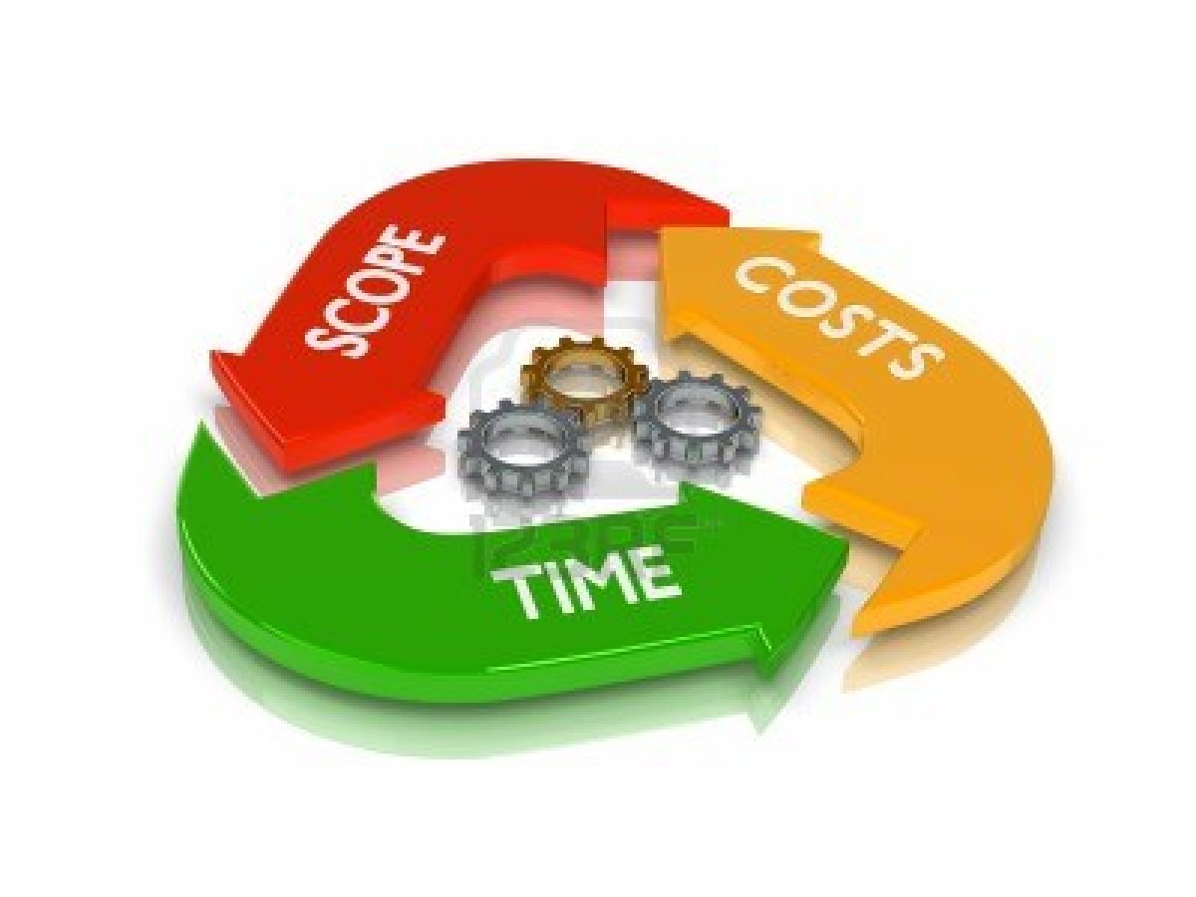
Outline
- Abstract
- History of Project Management
  - 19th Century Project Management
  - 20th Century Project Management
  - Project Management Today

- Importance of Project Management
  - Importance of Understanding Project Management
  - Importance of Projects to a Business
  - Why Project Managers are Important
  - A World Without Project Management

- Project Types & Classifications
  - Types of Projects
  - Project Classification

- Conclusion
- References

Abstract

Project Management evolvement can actually be dated back as far as centuries ago. It is thought that there were signs of project management involved in large ancient projects such as the Egyptian Pyramids building which took much planning and guiding of resources to complete. With that being said, project management may not have been actually considered a discipline, practice or strategy at the time, but was important. Today project management is important as or even more important than it ever has been. Almost every company utilizes project management in some form. The more people within those companies understanding the best practices the more effective they can be at managing and being part of a project management team. Projects are often viewed in different ways depending on the end result in mind. Therefore there can be different types and classifications of projects. In this paper I will provide details on the history and importance of project management as well as the different types and classifications of projects.

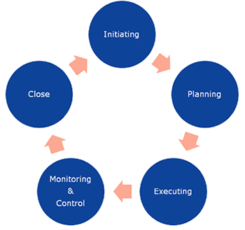

The History of Project Management
2.1 - 19th Century Project Management
The history of project management demonstrates the growth and importance. Ancient structures and buildings are just a couple examples of project management dating back to centuries ago. It took numerous resources and management of those resources to plan and eventually build the structures and buildings. In the 19th century, in the United States, large-scale government projects were the impetus for making important decisions that became the basis for project management methodology such as the Transcontinental Railroad, which began construction in the 1860’s. Suddenly business leaders found themselves faced with the daunting task of organizing the manual labor of the thousands of workers and the processing and assembly of unprecedented quantities of raw materials (Barron & Barron, 2011). The structured process and approach to managing the project would pave the way to future project management development.

2.2 – 20th Century Project Management
Henry Gantt is a well-recognized person for his project management related studies and the chart he developered in the early 20th century, called the Gantt Chart (Figure 1).
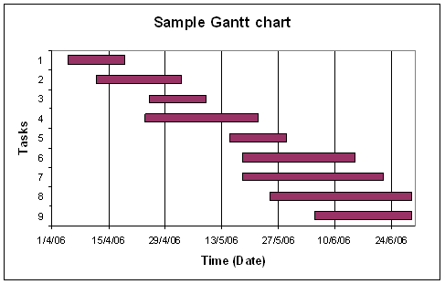
Figure 1 – Sample Gantt Chart

A Gantt chart is a popular type of bar chart that illustrates a project schedule and has a common technique for representing the phases and activities of a project work breakdown structure, so they can be easily understood by a wide audience (Barron & Barron, 2011). Large projects such as the Manhattan Project and the Pennsylvania Turnpike took place in early 20th century. At that time there still wasn’t a true structure or clearly defined methodologies for project management. It is said that those projects leaned on un-established techniques and/or tools such as the Gantt chart to plan, schedule, and manage the projects. The 1950’s marked the beginning of the modern project management era with two mathematical project-scheduling models (Barron & Barron, 2011).
- The Program Evaluation and Review Technique
- The Critical Path Method (CPM)
The 1950s brought forth a more robust form of project management beyond the foundation areas of cost, schedule, and technique performance (Cleland & Ireland, 2007). Moving further into the 20th century there would be more development, structure, and methodology. In 1969 the Project Management Institute (PMI) was founded. PMI is a way for project managers to collaborate and share experiences. PMI developed the PMP certification in 1984 as a way to recognize individuals who demonstrate a profound knowledge and understanding of project management. PMI didn’t stop there however as they introduced the Project Management Body of Knowledge (PMBOK) in 1987. In 1999 PMI was accredited as an American National Standards Institute (ANSI) developer and also has the distinction of being the first organization to have its certification program attain International Organization for Standardization (ISO) 9001 recognition (Barron & Barron, 2011).
2.3 – Project Management Today
Project management today is still evolving and advancing. The present project management practices, while still not perfect, are being employed to create change through the efficient use of resources to deliver predetermined benefits (Cleland & Ireland, 2007). Today you will find more project managers than ever. The Project Management Institute, headquartered in the United States, has experienced rapid growth in the past five years to now total more than 230,000 members (Cleland & Ireland, 2007).

Importance of Project Management
3.1 – Importance of Understanding Project Management
Companies today are constantly taking on projects or may even be project driven. That is why it is important for even those who are not project managers to understand project management. Those who may not lead a project still have a significant chance that they may someday be part of a project team. As a team member or a project manager, the more that is understood about project management, the more effective that person can be.

3.2 – Importance of Project to a Business
Companies are constantly changing and adapting in order to stay competitive in their market. Typically these changes or adaptations have to be accomplished through projects. Therefore, projects become essential to the success of a business. The success of the projects can ultimately define the success of the company. Projects are commonly a type of investment and unsuccessful projects can incur losses for the company.

3.3 – Why Project Managers are Important
Essentially the project manager has the most vital role in a project team. They can be viewed as the gravity point of a project as they assist with making all the pieces come together to deliver. Project managers also offer many advantages for projects. The can assist with obtaining excellent product quality and developing adequate communication. Improper communication among employees can lead to misunderstandings and negatively impact the performance (Pandey, 2012). Another advantage of project managers is that they can help reduce risks. With the guidance of a project manager the project management team can identify potential risks, take their time to rectify them and help the company save some valuable resources (Pandey, 2012). Additional benefits from having a project manager are developing strategic objectives and goals, as well assisting with crisis management.

3.4 – A World without Project Management
Without project management collectively we would not be as successful in completing the tasks and challenges we face. Companies would also struggle with change and adaptation. Thus companies would not be as successful as they are with project management. As Wheatley (n.d.) states, innovation relies on project management, whether the innovation concerns a new product, or a new process, or indeed a contribution to pure science, project management, on the whole, will see a successful outcome reached more quickly, having consumed fewer resources. Without project management, project-intensive industries would potentially be non-existent.

Project Types & Classifications
4.1 – Types of Projects
Understanding project types is important as it helps to determine whether or not project management is necessary and if it is, how to effectively use it based on the type of project. Each project may require a deviated approach based on its type. The three common project types are product, service, and continuous improvement. Cleland & Ireland (2007) defines the project types as follows:
- Product Projects – Projects that design, develop, and deliver a product as a result of the work effort. The customer for this project is typically an external stakeholder.
- Service Projects – Projects that plan, design, and deliver services to external customers. The customer has contracted for specific expertise that is not available in-house.
- Continuous Improvement Projects – Projects that are internal to the organization and result in process change. The customer is an internal manager, or group of managers, who wants to change the manner in which current operations occur.

4.2 – Project Classification
There are three common classifications of projects which includes compliance, operation, and strategic. Gray & Larson (2008) define each of the classifications as follows:
- Compliance projects are typically those needed to meet regulatory conditions required to operate in a region.
- Operational projects are those needed to support current operations.
- Strategic projects are those that directly support the organization’s long-run mission.

The three classifications are really the foundation for classifying the project. Within classifications there are also feature areas. Each of the twelve feature areas, as outlined by Cleland & Ireland (2006), can be seen in the table below (Table 1). This list can help understand the project, whether from an organization’s perspective or from a customer’s perspective.

Size |  |  | Profitability | Technology
Dollar Value |  |  | High Margin | Low Technology
Number of people on project |  |  | Medium Margin | Medium Technology
Duration |  |  | Low Margin | High Technology
Geographic Span |  |  | No Margin | Mature Technology
Combintaion of above |  |  | Loss | Immature Technology
Business Experience |  |  | Business Base | Project Definition
Project Done Before |  |  | Builds On Core Competencies | Undefined
Project Not Done Before |  |  | Builds New Core Competencies | Ill-defined
Project Has Some New Work |  |  | Unrelated Core Competnecies | Partially Defined
Project Never Done Before |  |  | Leverage Core Competencies | Fully Defined
Priority |  |  | Degree of Risk | Cash Flow
Urgency for Business |  |  | High | Immediately ROI
Urgency for Customer |  |  | Medium | Near-term ROI
Urgency to meet market reqs. |  |  | Low | Long-term ROI
Results (objectives) |  |  | Deliverables | Other Features
Strategic |  |  | Product | Engineering
Operation/business |  |  | Product and Service | Research
Part of Larger Program |  |  | Service | Production (same parts)
 |  |  | Product Improvement/upgrade | Production (several models)
 |  |  | Product Disposal | One-of-a-kind Product
 |  |  | Product Restoration | Protoype Product
 |  |  | Product Maintenance
 |  |  | Emergency Operations
 |  |  | Legal Services
 |  |  | Law Enforcement
 |  |  | Political Campaigns
Table 1 - List of Feature Areas for Project Classification

Conclusion
The history of project management has laid a solid foundation for what project management is today. Due to the work of many individual’s studies and to organizations like PMI, we now have structure to project management practice and methodologies. Through certifications and other higher education we now have a way to formally prepare people to work in the field and recognize people for project management skills. That is important because project management is essentially found in almost every business now and having skilled and knowledgeable project managers and project team members can be of great overall value to almost any company.
References

Gray, C.F. & Larson, E.W. (2008). Project management: the managerial process (4th ed.). New York, NY: McGraw-Hill.

Cleland, D.I. & Ireland, L.R. (2007). Project management: strategic design and implementation (5th ed.). New York, NY: McGraw-Hill.

Wheatley, M. (n.d.). The importance of project management. Retrieved from http://www.projectsmart.co.uk/the-importance-of-project-management.html

Pandey, K. (2012). Why is project management important. Retrieved from http://www.buzzle.com/articles/why-is-project-management-important.html

Harbour, S. (n.d.). Why is it important for organizations to use project management? Retrieved from http://smallbusiness.chron.com/important-organizations-use-project-management-46723.html

Barron, M. & Barron, A.R. (2011). History of project management.PM Hut. Retrieved from http://www.pmhut.com/history-of-project-management

Bista, B. (n.d.) Project management: history and evolution. Retrieved from http://ezinearticles.com/?Project-Management-History-and-Evolution&id=340860

